**ECEN 106 Laboratory: Keypad and Display**

**Important Note:** There are two versions of the lab kit sold by the bookstore. The LCD screens are different between the two kits. If your screen has the 4-pin connector soldered to the back of the screen as shown below, or if you can borrow a 4-pin LCD screen from an on-campus ECEN 106 instructor, then use these instructions. If your screen does *not* have the 4-pin connector and instead has 16 pins available, you should instead follow the lab instructions at:

<https://content.byui.edu/file/6fce7410-fa48-4b8b-9acb-ef5328928e9f/1/Laboratories/Keypad%20and%20Display/Keypad%20and%20Display%20Laboratory%20Instructions%20%28with%2016-pin%20screen%29.pdf>

Only continue with the following instructions in this document if you have a **4-pin connector** on the back of your screen, like the left and center images below.

|  |  |  |  |
| --- | --- | --- | --- |
|  | LCD *with* 4-pin connector | LCD *with* 4-pin connector (note: pin order is reversed compared to first screen) | LCD *without* 4-pin connector (16 pins available)  **\*\*\*use other instructions\*\*\*** |
| Front  Back |  |  |  |

Overview

This laboratory has three parts. First, you will connect a liquid crystal display (LCD) to the Arduino and display a message. Second, you will type a short message on your computer and display it on the LCD. Third, you will connect a 4x4 matrix keypad to the Arduino and display its key presses on the LCD.

Background

How Liquid Crystal Displays (LCDs) Work

The screen of LCDs is made of pixels. Text is created using these pixels, and the programmer can control each individual pixel. Characters are displayed by controlling the pattern of the pixels.

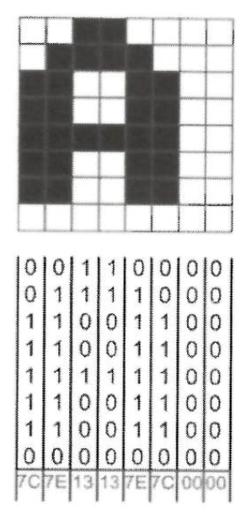

*Figure 1*

LCDs can be monochrome (mono-colored) or colored. In monochrome LCDs, each pixel can be on or off, or different shades of gray. In colored LCDs, each pixel can have different colors. The colored pixels can display red, green, and blue. The three primary colors can be combined to make different colors.

How Keypads Work

Buttons on a keypad are arranged in a matrix of rows and columns. A 3x4 keypad has four rows and three columns. A 4x4 keypad has four rows and four columns.

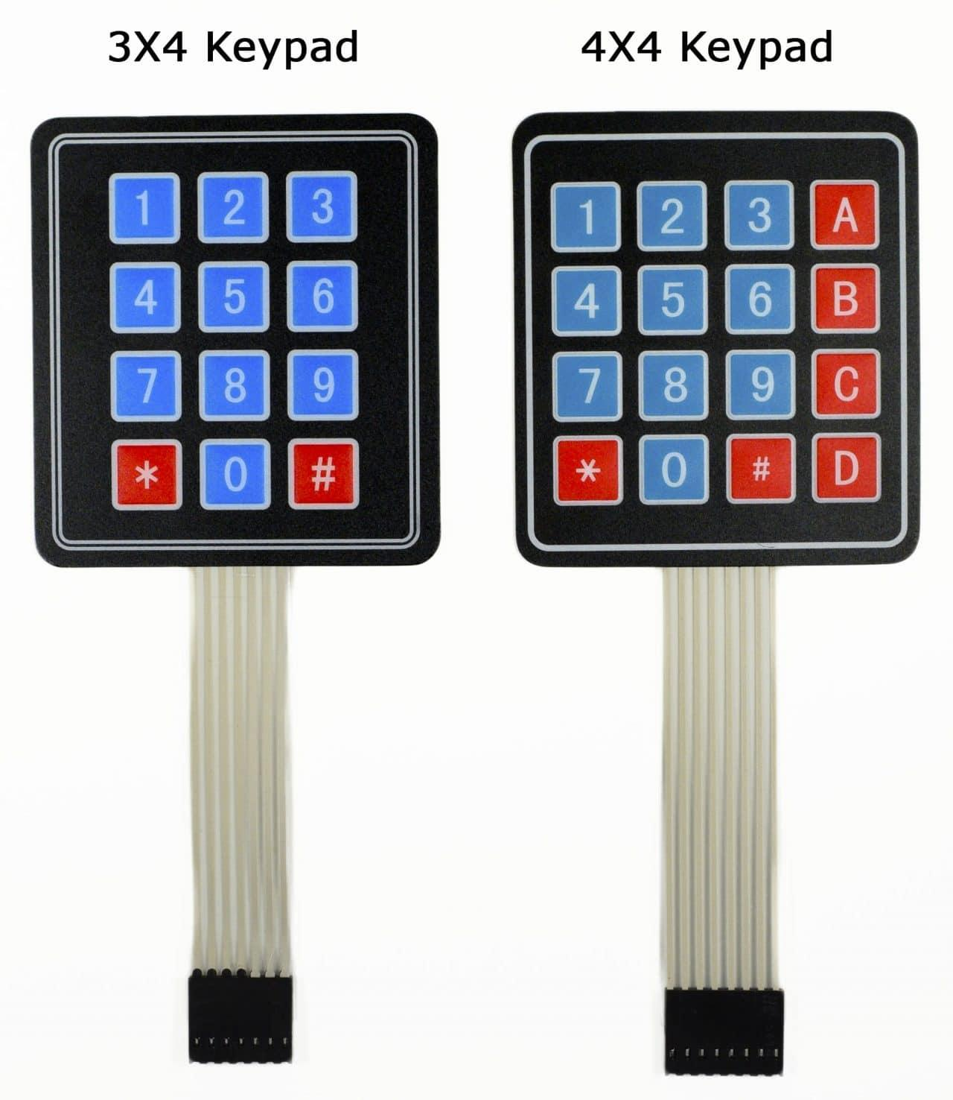

*Figure 2*

Beneath each key is a membrane switch, like those used for many computer keyboards. Each switch in a row is connected to the other switches in the same row by a conductive trace underneath the pad. The switches in a column are connected the same way; one side of the switch is connected to all the other switches by a conductive trace. Each row and column are brought out to a single pin, for a total of eight pins on a 4x4 keypad.

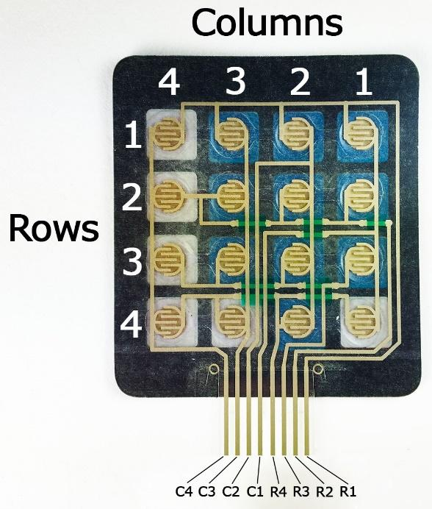

*Figure 3*

Pressing a button closes the switch between a column and a row trace, allowing current to flow between a column pin and a row pin. The Arduino determines which button is pressed by detecting the row and pin that is connected to the button.

This happens in four steps:

1. When no buttons are pressed, all the column pins are held HIGH, and all of the row pins are held LOW.

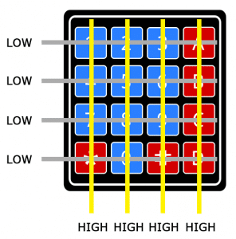

*Figure 4*

1. When a button is pressed, the column pin is pulled LOW because the current from the HIGH column flows to the LOW row pin.

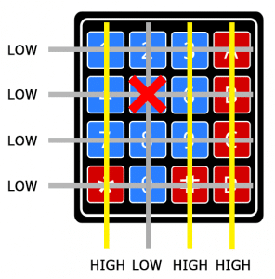

*Figure 5*

1. The Arduino now knows which column the button is in, so now it needs to find the row it is in. It does this by switching each one of the row pins HIGH, and at the same time reading all the column pins to detect which column pin returns to HIGH.

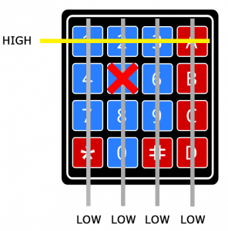

*Figure 6*

1. When the column pin goes HIGH again, the Arduino has found the row pin that is connected to the button.

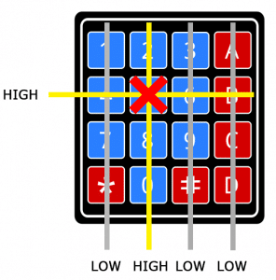

*Figure 7*

Computer keyboards work on the same principle. A simple processor in the keyboard performs the same function as the Arduino does in this example. It then notifies the computer which key has been pressed.

Required Equipment and Materials

* Computer with Arduino IDE software installed (1)
* LAFVIN Super Starter Kit for UNO R3 (1), containing the following items:
* Arduino UNO with USB Cable (1)
* 4-pin I2C Enabled 1602 16x2 LCD (1)
* 4x4 Matrix Keypad (1)
* Male-to-Female Jumper Wires (4)
* Male-to-Male Jumper Wires (8)

Part 1: Connect and Test the Liquid Crystal Display (LCD)

In this part of the laboratory, you will connect a liquid crystal display (LCD) to the Arduino and display a message. These instructions are for the **I2C-enabled 1602** which is included in the kit from the BYU-Idaho Bookstore. It has a small daughter board with a 4-pin connector soldered to the back of the LCD1602 as shown in Figure 8. (If your 4-pin connector is red, these instructions will still work—just note that the pin order is different.)

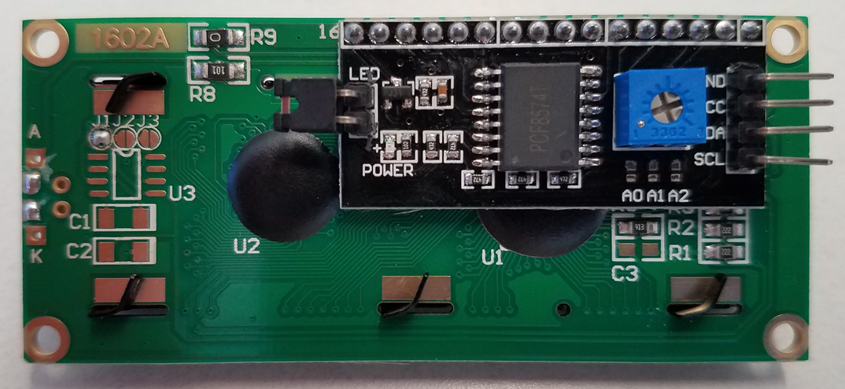

*Figure 8*

* + - 1. Install the LiquidCrystal I2C Library written by Marco Schwartz by following these steps:
         1. Download the [LiquidCrystal_I2C library](https://content.byui.edu/file/6fce7410-fa48-4b8b-9acb-ef5328928e9f/1/Laboratories/Keypad%20and%20Display/LiquidCrystal_I2C.zip).
  1. From the Arduino IDE, select **Sketch > Include Library > Add .Zip Library**. Figure 9 demonstrates the path.
  2. Navigate to your Download folder and open **LiquidCrystal_I2C.zip.**

*Figure 9*

2. Connect the 1602 LCD to the Arduino Uno by following these steps:

**NOTE**: The male-to-female jumpers are joined together in a ribbon in the kit; you may separate the wires to complete the next steps. As a reminder, the color of the wires doesn’t matter. The color just helps you keep track of the wires. Typically, we use blue for ground (LOW) and red for VCC (HIGH).

a. Connect GND on the LCD to GND on the Arduino with a male-to-female jumper.

b. Connect VCC on the LCD to 5V on the Arduino with a male-to-female jumper.

c. Connect SDA on the LCD to A4 on the Arduino with a male-to-female jumper.

d. Connect SCL on the LCD to A5 on the Arduino with a male-to-female jumper.

e. Your connections should look like the diagram in Figure 10 below. **Please look at the names of the pins, as different screens have a different pin order.**

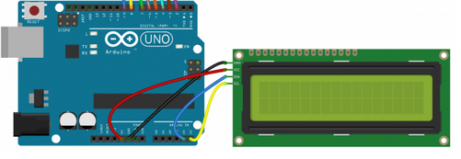

*Figure 10*

3. Download and run the sketch by following these steps:

a. Download [HelloWorld.ino](https://content.byui.edu/file/6fce7410-fa48-4b8b-9acb-ef5328928e9f/1/Laboratories/Keypad%20and%20Display/HelloWorld/HelloWorld.ino). This file has the code. The Arduino IDE calls code files “sketches.”

b. From within the Arduino IDE, go to File -> Open, navigate to your Downloads folder, and the select the HelloWorld.ino file. It may ask you to put the sketch in a folder of the same name. If it does, select **OK**. The Arduino IDE will open, showing the HelloWorld sketch.

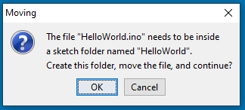

*Figure 11*

c. Make sure that the correct board and port is selected in the dropdown menu (Figure 12).

*Figure 12*

d. Select the **Upload** button, shown circled in red in Figure 13.

*Figure 13*

e. After the sketch compiles and downloads, the LCD will display the message “Hello, world! ECEN 106 is fun!” (See Figure 21).

f. If you do not see a message, check your wiring. If you still do not see the message, try turning the screw on the I2C module on the back of the LCD. The screw controls the brightness of the display.

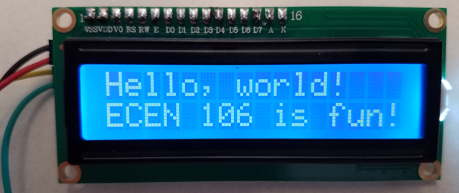

*Figure 14*

g. Edit the sketch to display your first name on the top line and your last name on the bottom line. While editing the sketch, be sure to leave the quotation marks in the code.

h. Select the download button again to display your name.

i. Take a photo of the display showing your name and submit it in JPG format for your laboratory report.

Part 2: Send Computer Key Presses to the LCD

In this part of the laboratory, you will type a short message on your computer keyboard and display it on the LCD.

1. Download and run the sketch by following these steps:

a. Download [SerialDisplay.ino](https://content.byui.edu/file/6fce7410-fa48-4b8b-9acb-ef5328928e9f/1/Laboratories/Keypad%20and%20Display/SerialDisplay/SerialDisplay.ino).

b. Go to File->Open, and navigate to and select the **SerialDisplay.ino** file (likely in your Downloads directory). A popup window titled **Moving** will open.

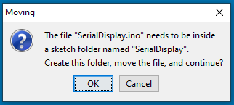

*Figure 15*

c. If so, select **OK**. The Arduino IDE will open, showing the SerialDisplay sketch.

d. Select the correct Board/Port from the dropdown menu. Then press the **Upload** button.

e. Select the **Serial Monitor** button, shown circled in red in Figure 16.

*Figure 16*

f. The console window will open. See Figure 17.

What symbol is a new line (“Enter”)

Transmission rate

Where you see a received message

Where you type a message to send

*Figure 17*

g. Type a short message in the console, then press **Enter** on your keyboard. The message will appear on the LCD. See Figure 18 for an example.

This is a test.

*Figure 18*

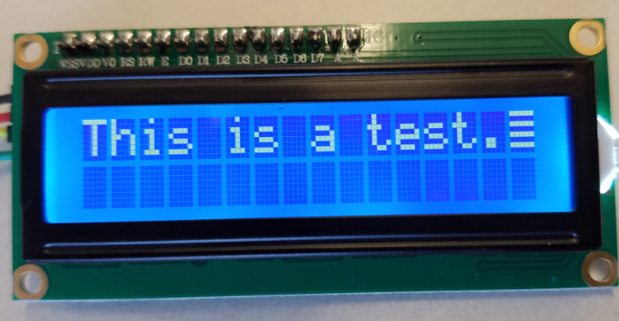

*Figure 19*

h. Take a photo of the display showing your message and submit it in JPG format for your laboratory report.

Part 3: Connect and Test the 4x4 Matrix Keypad

In this part of the laboratory, you will connect a 4x4 matrix keypad to the Arduino and display its key presses on the LCD.

1. Install the Keypad Library written by Mark Stanley and Alexander Brevig by following these steps:

a. From the Arduino IDE, select **Sketch > Include Library > Manage Libraries**. Figure 20 demonstrates the path.

*Figure 20*

b. When the Library Manager window opens, search for **keypad** and scroll down to **Keypad by Mark Stanley, Alexander Brevig**. (It may also be named **Keypad by Community https://github.com/Chris--A/Keypad.**)See Figure 21 for an example.

*Figure 21*

c. Select **Install**. Keypad will be listed under the heading of Contributed Libraries.

2. Connect the 4x4 matrix keypad to the Arduino Uno by following these steps:

a. Connect **pin 1** (far-right pin) of the keypad to **pin 2** of the Arduino with a male-to-male jumper.

b. Connect **pin 2** of the keypad to **pin 3** of the Arduino with a male-to-male jumper.

c. Connect **pin 3** of the keypad to **pin 4** of the Arduino with a male-to-male jumper.

d. Connect **pin 4** of the keypad to **pin 5** of the Arduino with a male-to-male jumper.

e. Connect **pin 5** of the keypad to **pin 6** of the Arduino with a male-to-male jumper.

f. Connect **pin 6** of the keypad to **pin 7** of the Arduino with a male-to-male jumper.

g. Connect **pin 7** of the keypad to **pin 8** of the Arduino with a male-to-male jumper.

h. Connect **pin 8** (far-left pin) of the keypad to **pin 9** of the Arduino with a male-to-male jumper.

i. Your connections should look like the diagram in Figure 22.

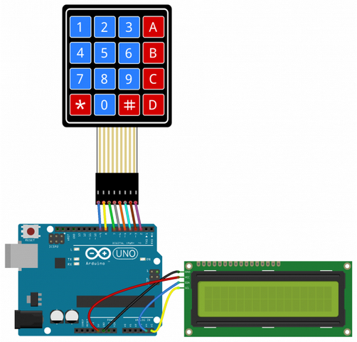

8

1

*Figure 22*

3. Download and run the sketch by following these steps:

a. Download [KeyPadDisplay.ino](https://content.byui.edu/file/6fce7410-fa48-4b8b-9acb-ef5328928e9f/1/Laboratories/Keypad%20and%20Display/KeyPadDisplay/KeyPadDisplay.ino).

b. Select **KeyPadDisplay.ino** in your Downloads directory. The popup window shown in Figure 23 will open.

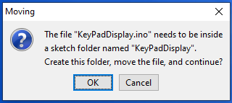

*Figure 23*

c. Select **OK**. The Arduino IDE will open, showing the KeyPadDisplay sketch.

d. Select the **Upload** button.

4. Test your configuration by following these steps:

a. Press a key on the 4x4 matrix keypad. The pressed key will appear on the LCD.

b. Make a short video that demonstrates correct operation and submit it in MP4 format for your laboratory report.

Submit Your Laboratory Report

Submit your two JPG photos (one for Part 1 and one for Part 2) and short MP4 video (for Part 3) through Canvas. No written report is required.